Federal Grant At-Risk Funding Appeal Templates

SMS:

SMS (372~ characters)

Hi [Name], this is [Your Name] from [Name of Organization]. You may have heard that federal grant funding is at risk for being paused or eliminated for many vital programs across the nation. While much remains uncertain, I hope that we can count on your support. Our funding is at risk, but your emergency gift now will help ensure stability, no matter what challenges we may face. [link]

Email Copy: Informative and Urgent Versions

Template #1: Informative Appeal

Email Image:
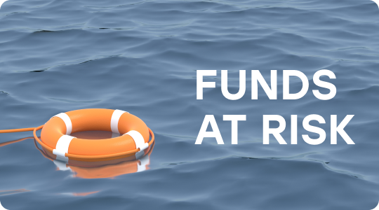

Subject: How federal grant changes could impact our shared mission
Pre-Header: Here’s what you can do to make a difference.

Hi [Name],

As you may have heard, federal funding is at risk for vital programs and services across the nation. While much remains uncertain, [Nonprofit] is vulnerable to a critical funding gap that could directly threaten our ability to [insert mission: e.g. respond and deliver aid to people across the world who are in need].

[Name], I’m writing to you with an urgent request. Will you make an emergency gift today to help us continue to provide critical services?

[CTA: Make Your Emergency Gift]

We are turning to our most dedicated supporters — like you — to help us weather this storm of uncertainty. No matter what decisions are made going forward, we are grateful for your support and continued advocacy for our mission.

With gratitude,
[SIGNATURE]

P.S. You can make a long-term impact by upgrading your support to a monthly gift. A monthly gift will ensure our mission has reliable support while federal funding is at risk.

Template #2: Urgent Appeal

Email Image:
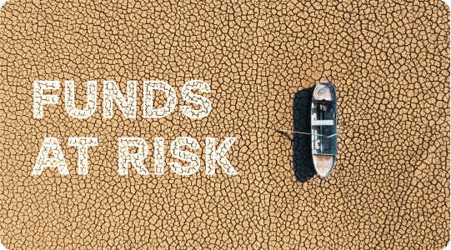

Subject: We’re at risk of losing [a third] of our funding
Pre-Header: Your emergency gift today will help [Nonprofit] continue supporting those who rely on us.

Hi [Name],

The news is alarming. [Nonprofit] is at risk of losing a significant portion of our total funding, pending freezes or changes to federal grant funding.

In addition to the generosity of our donors and supporters, [Nonprofit] relies on federal grant funding to support our mission and important initiatives <like example initiative #1, example initiative #2 and example initiative #3 >.

Here’s the bottom line: federal grant funding is at risk, which puts our mission at risk.

While much remains uncertain, you can make a difference right now. Will you make an emergency gift today to help us continue our important work?

[CTA: Make Your Emergency Gift]

Your donation at this time will make an immediate impact, enabling us to maintain our operations and continue supporting those who rely on us.

No matter what decisions are made going forward, we are grateful for your support and continued advocacy for our mission.

With gratitude,
[SIGNATURE]

P.S. You can make a long-term impact by upgrading your support to a monthly gift. A monthly gift will ensure our mission has reliable support while federal funding is at risk.

